Reflection Questions
Wellness Themes
How can I manage uncertainty?
What are some ways I can foster self-compassion?
How can I promote healthy engagement with work challenges?
Professional Values
Why did I choose to become a nurse?
What do I believe in?
What will I stand up for?
How have I grown and developed as a nurse?
Learning from the Past
What kinds of events have been most stressful for me?
How have those events typically affected me?
Who have I reached out to for support in working through a stressful experience?
How have I been able to overcome obstacles?
What has helped make me feel more hopeful about the future?

Online Assessment Tools & Planning Templates
Resiliency Test
Resiliency Plan Template
Self-Care, Values & Strengths Resources
Self-Care Assessment & Planning
Self-Care Exercises & Activities
Self-Care Tip Sheet
Strengths Test

Stories of Resiliency
20 Books about Resiliency
Book: The resilient nurse: empowering your practice by McAllister, M., & Lowe, J. B. (Eds.). (2011).
Podcast: The Happiness Lab
Mindfulness & Meditation Practice
Mindfulness Practice for Healthcare Providers
Apps: Insight Timer, Headspace, CALM, Stop, Breath & Think, iMindfulness, 10% Happier: Meditation, Mindfulness Daily, The Mindfulness App
Book: The Gift of Presence: A Mindfulness Guide for Women by Welch, C. (2020).
Podcast: Making Sense with Sam Harris, Episode #193-Meditation in an Emergency
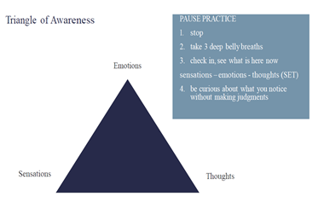
References
American Psychological Association (2020). The road to resilience. file:///C:/Users/Owner/Desktop/the%20road%20to%20resilience.pdf
Bass, J., Walters, C., Toohill, J., & Sidebotham, M. (2016). Promoting retention, enabling success: Discovering the potential of student support circles. Nurse Education in Practice. doi: 10.1016/j.nepr.2016.07.002
McAllister, M., & McKinnon, J. (2009). The importance of teaching and learning resilience in the health disciplines: A critical review of the literature. Nurse Education Today, 29, 371-379. doi: 10.1016/j.nedt.2008.10.011
Skovholt, T. M., & Trotter-Mathison, M. (2011). The resilient practitioner: Burnout prevention and self-care strategies for counselors, therapists, teachers, and health professionals (2nd ed.). New York, NY: Routledge Taylor and Francis Group.

Reframing
Reframing Exercise
Reframing Worksheet

Contact Rebecca Low at rebecca.low@ualberta.ca if you have any questions or would like additional information

