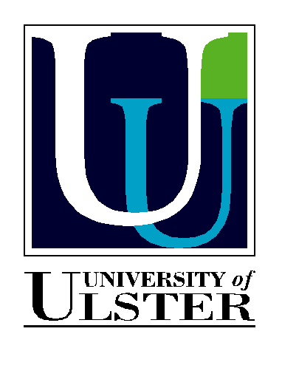

Welcome to KU04

Dear Colleague,
Thank you for agreeing to attend the Knowledge Utilisation Colloquium 2004 (KU04) which will be held in Belfast Northern Ireland.

The purpose of this communication is to update you on progress and arrangements.

Dates of KU04 - 26th and 27th July
Venue - Wellington Park Hotel, Malone Road, Belfast

The aims of KU04 are to:
- Further methodological understandings of 'measurement' in knowledge utilisation
- Explore the concept of 'facilitation' and its place in the translation of knowledge into practice

Programme: Please see draft programme attached.

Presentations
A gentle reminder to speakers re the 1500 word paper - please could I have this in word format by the 12th July.
I would also appreciate a copy of the PowerPoint you are using for insertion in the colloquium packs. Please could I have these by the 19th July

Student Event
Jonathan Jewell from the RCN is leading the organisation of this part. It will take place on the 25th July (Sunday) and will be held at the Royal Hospitals Trust, Belfast. If you are a student and are intending to attend the student event then please contact Jonathan directly at jonathan.jewel@rcn.org.uk

Accommodation
If you have not already sorted out your accommodation then please can you contact the Wellington Park Hotel directly and quote reference ROY25074 (the room rate is £79 single room and £91 double room [prices quoted in pounds sterling]. The price is inclusive of full Irish breakfast! Visit http://www.travel-ireland.com/wellpark/ to find out more about the venue & accommodation. We have ‘blocked’ 40 rooms for the nights of the 25/26/27 of July. Please could you reserve a room as soon as possible (if you intend to) as otherwise we (The Royal Hospitals) will start to incur charges. For alternative hotels visit http://www.holidaycityeurope.com/belfast-hotels/
Travel
Many of you may be coming from Dublin (following the EBP conference) to Belfast for the event. There is an excellent train service (2 hours) between Dublin and Belfast (considered to be the only decent train in Ireland!!). Visit http://www.translink.co.uk/enterpriseservices.asp to find out more about this service. For those of you who may be travelling directly from Europe, Australia, USA or Canada, the only direct way to get here is via one of the main airports in England or Scotland and then a connecting flight to Belfast. British Midland is the main carrier between London Heathrow and Belfast City Airport visit http://www.flybmi.com/bmi/en-gb/index.aspx to find out about their timetables. A variety of budget flights connect Belfast and England/Scotland. The main ones being:
- Easy jet http://www.easyjet.com/
- BMI baby http://www.bmibaby.com/bmibaby/en-gb/index.aspx
- Flybe http://www3.flybe.com/obs/booking-controller/

Belfast City Airport (only British Midland and Flybe fly to here) is 10 minutes taxi ride from the Wellington Park Hotel.
Belfast International Airport (Easyjet and BMI baby fly to here) is 18 miles out of Belfast. There is a regular bus into Belfast City Centre (and then a 5 minute taxi ride to the hotel) or a direct taxi would cost you approx £25.

Alternatively ... fly to Dublin and get the previously mentioned train to Belfast!

Dinner
Belfast is rapidly becoming a ‘culinary retreat!’ and so in order to give participants a flavour of that, we have booked our ‘colloquium celebratory dinner’ on the 26th July in a new Belfast Restaurant called ‘James Street South’. If you intend to bring a partner/friend to this dinner then please could you let Brendan (via Jennifer Dundas Jennifer.dundas@royalhospitals.n-i.nhs.uk) know as soon as possible. The dinner for participants is being supported by the University of Ulster School of Nursing and is free to participants. Guests of participants will be required to pay.

Belfast in General
For any general information about Belfast visit this web site:
http://www.gotobelfast.com/home

or Northern Ireland in general visit these web site:s
http://www.geographia.com/northern-ireland/
http://www.nitb.com/

