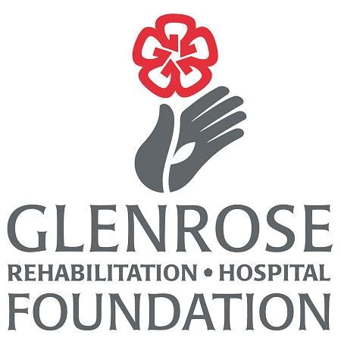


2024
Dr. Peter N. McCracken Legacy Scholarship

DESCRIPTION OF AWARD:
The Dr. Peter N. McCracken Legacy Scholarship is made possible by donations in recognition of Dr. McCracken’s many contributions to geriatric medicine and to the mentorship of students. The purpose of the scholarship is to provide granting opportunities to enable students to participate in research activities.

VALUE AND DURATION:
Up to two scholarships of $1,500 each may be awarded annually.

ELIGIBILITY:
The applicant is registered in a graduate (Masters, PhD, or MD) program (course based or thesis based) at the University of Alberta with a focus on geriatrics/gerontology. Disciplines include, but are not limited to, medicine, rehabilitation medicine, nursing, pharmacy, and psychology.

As part of the conditions of the award, at the end of one year, the successful grant recipient(s) is required to submit a one-page summary of their project to the selection committee as well as present at Geriatric Grand Rounds held at the Glenrose Rehabilitation Hospital.

An applicant may not hold this scholarship more than once.

SELECTION PROCESS:
Selection of the recipient(s) will be made by a committee appointed by the Director, Older Adult Rehabilitation. Selection will be based on academic merit, as indicated by grades and indices of professional development, research plans and commitment to the field of geriatrics/gerontology. The Scholarship Award recipient will be acknowledged at Geriatric Grand Rounds, Dr. Peter McCracken Memorial Lecture and at the meeting of the GRH Foundation Board.

APPLICATION DEADLINE:
Completed applications must be received by 4:00 pm august 16, 2024 (late applications will not be accepted)
to: Brian.Schmidt@albertahealthservices.ca (electronic application packages preferred)

OR hardcopy application packages to:

Dr. Peter N. McCracken Legacy Scholarship
Glenrose Rehabilitation Hospital Foundation
10230 – 111 Avenue
Edmonton, AB T5G 0B7
ATTN: Brian Schmidt, Director, Older Adult Rehabilitation

APPLICATION PROCEDURE:
A complete application will consist of three parts:
- Completed application form
- A brief statement of future plans for pursuing a career in the field of geriatrics/gerontology (1 page maximum)
- A description of research project and anticipated completion date (1 page maximum)
- One copy of the applicant’s curriculum vitae.
- Copy of official university transcripts (original transcripts not required).
- A brief letter of support from an individual (not related and normally this would be the student’s academic supervisor), who can comment on the applicant’s research capacity and interest in the field (maximum of 1 page).

2024
Dr. Peter N. McCracken Legacy Scholarship

Please Print or Type

Last Name:

First Name: Initial:

Home
Address:

Postal
City: Province: Code:
Phone: Email:

Faculty: Department:

Program: Year in Program:

Supervisor (if applicable):

Applicant
Signature: Date:

Please attach the following, using 12 pt. font, 1-inch margins, and single spacing:
- Completed application form
- A brief statement of future plans for pursuing a career in the field of geriatrics/gerontology (1 page maximum)
- A description of research project and anticipated completion date (1 page maximum)
- One copy of the applicant’s curriculum vitae.
- Copy of official university transcripts.
- A brief letter of support from an individual (not related and normally this would be the student’s academic supervisor), who can comment on the applicant’s research capacity and interest in the field (maximum 1 page).

APPLICATION MUST BE RECEIVED BY 4:00 pm on, AUGUST 16, 2024
TO: Brian.Schmidt@albertahealthservices.ca (electronic application package preferred)

OR hardcopy application package to:

Dr. Peter N. McCracken Legacy Scholarship
Glenrose Rehabilitation Hospital Foundation
10230 – 111 Avenue
Edmonton, AB T5G 0B7
ATTN: Brian Schmidt, Director, Older Adult Rehabilitation

Late applications will not be accepted.

 
Office Use Only

Date Received: Received by:
Complete: Part 1  Part 2  Part 3  Part 4  Part 5  Part 6 

