Sample Driver Logs:

Five examples of driver logs from “New_HOS.pdf” by Ms. Kim Durdle, Director of Carrier Services, Alberta Infrastructure.

http://www.infratrans.gov.ab.ca/INFTRA_Content/docType276/Production/New_HOS.pdf.

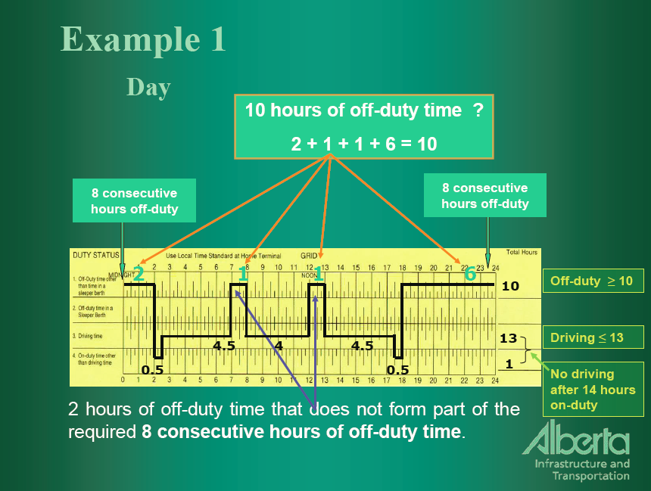

Have 8 consecutive hours off-duty and total of 10h off-duty in a day; have not exceeded 13h driving in a day. The total time for each state is written in the column at the far left side of the graph.
Note: none of our vehicles has a sleeper berth so line 2 will not be used.

Two periods of 0.25h off-duty don’t count because each is less than the 0.5h minimum duration. Also, you cannot put the 2h off-duty immediately before the 8 consecutive hours off-duty, the breaks are meant to occur during the work shift.
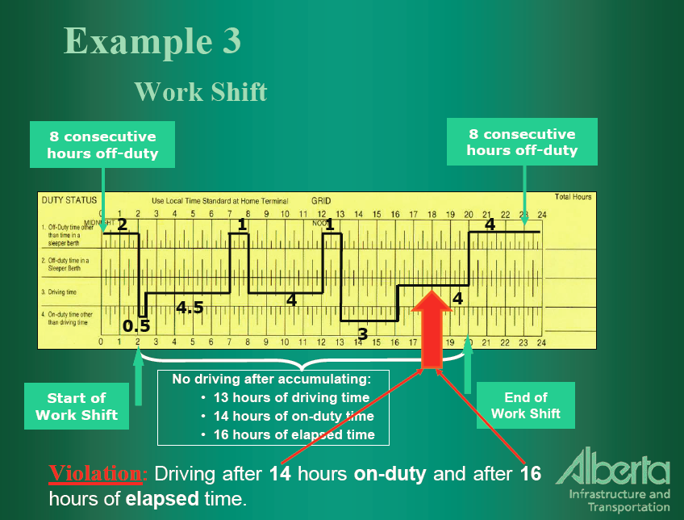
Did not have 8 consecutive hours off and are driving after 14h on duty.
Deferred off-duty time: Study #5 & 6 if you want. Refer to more detailed information on daily time restrictions that is available at the Government of Alberta website on Transportation and hours of service for commercial vehicles.

*********

