Notes corresponding to video http://tinyurl.com/mv690/video/assumptions

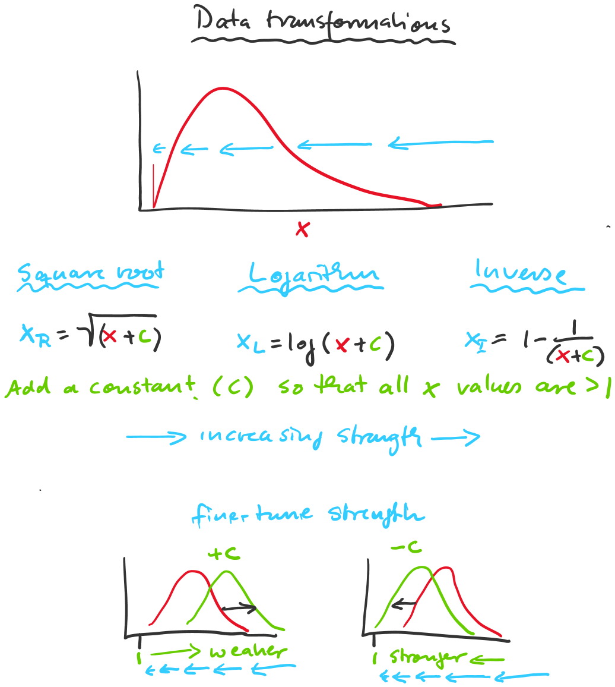

For a more detailed coverage of testing assumptions for univariate parametric statistical techniques, what matters and what doesn’t, see this video: http://tinyurl.com/rr480/video/assumptions

