Notes for video 6.1.: http://tinyurl.com/rr480/videos/sn-ratios

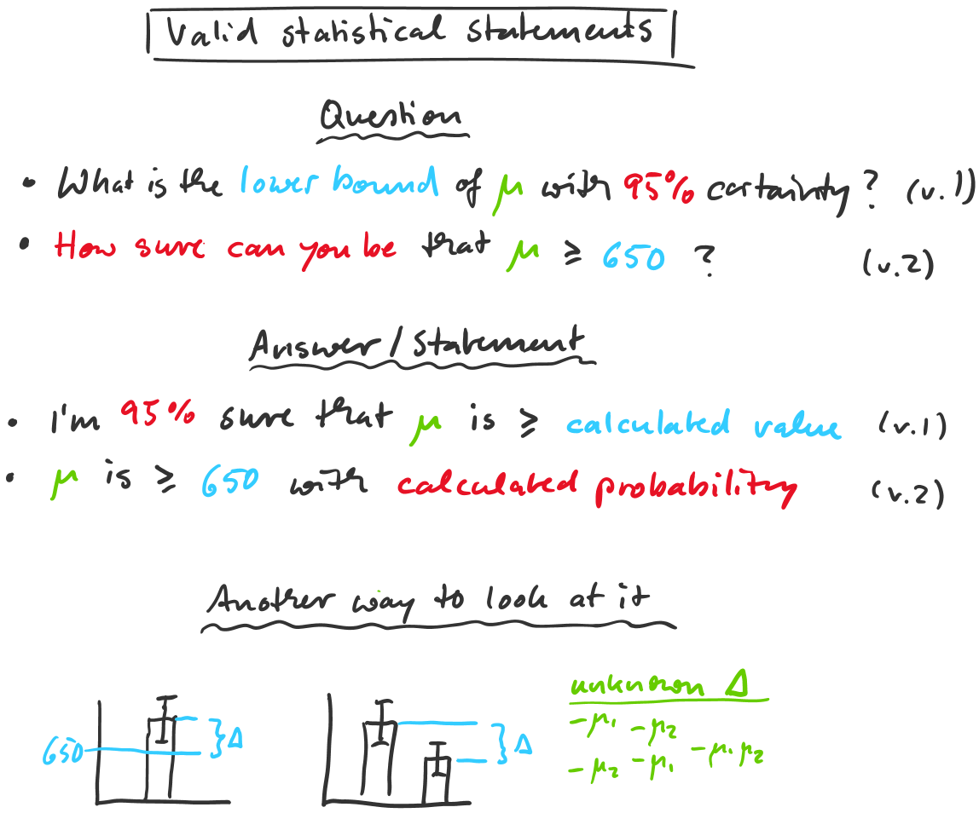

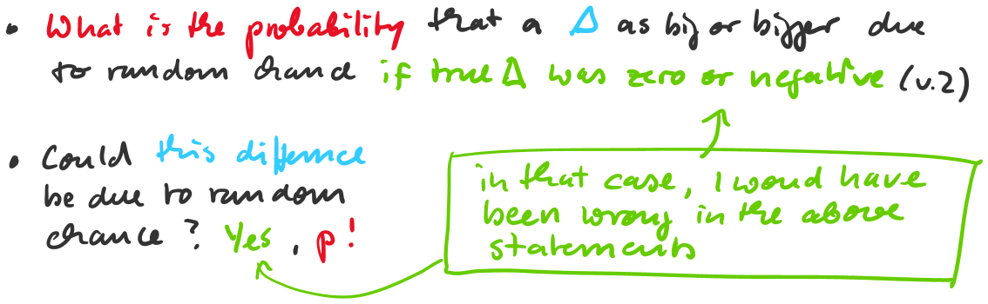

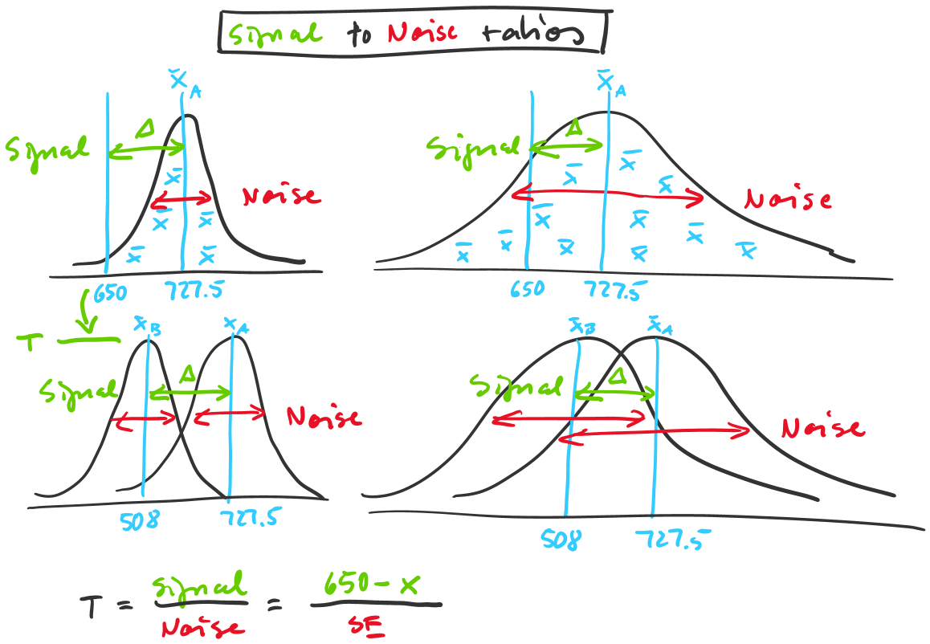

The test statistic (T, F, Z, X² …) is always a signal versus noise metric. Most of the time it’s a ratio, (but that can differ).
- A signal to noise ratio of 5.6 (normally) means: The signal is 5.6 times as large as the noise. I'm sure in my statement

- A signal to noise ratio of 1 (normally) means: Signal = Noise. I can't be sure.

- A signal to noise ratio < 1 (normally) means: Really not sure.

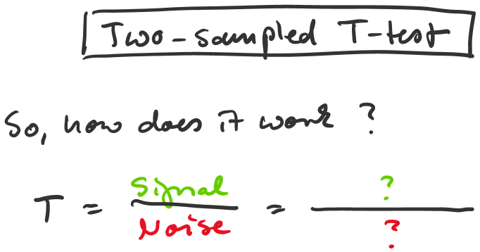

A = c(720,740,690,760)
B = c(515,480,545,492)

xA, xB, seA, seB ...?
T ...?
p ...?

t.test(A, B, alternative="greater")

